Style guide mogelijkheden

Soraya Timmers















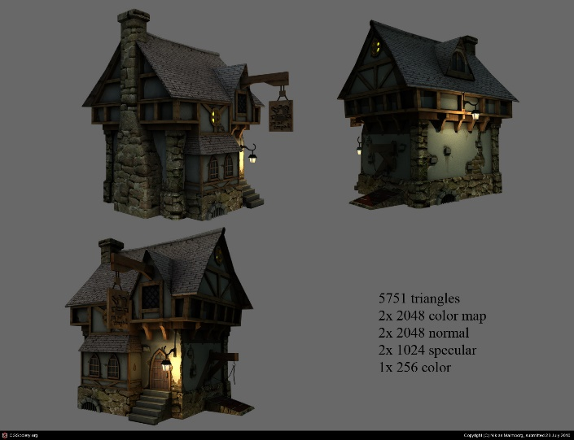





<https://www.youtube.com/watch?v=hl719WJ1BuE>

<https://www.youtube.com/watch?v=4R7g_3Z0qys>

<https://www.youtube.com/watch?v=zaeFASa4lr8>

<https://www.youtube.com/watch?v=qybaOGYNTPI>

<https://www.youtube.com/watch?v=qybaOGYNTPI>

<https://www.youtube.com/watch?v=aNeQ97o7KO8>

<https://www.youtube.com/watch?v=sslKkqwkBr0>

<https://www.youtube.com/watch?v=DfZOGUODKCg>

<https://www.youtube.com/watch?v=U_RM3coUgx4>

